

**Artificial Intelligence (COMP 360)**

**SECTION B**

**Final Project**

**Politics Social Media Sentiment Analysis**

**Group Members:**

**Ali Haider (241560771)**

**Nabeel Randhawa (241560260)**

**Rida Noor (241548037)**

**Faheem Mahmood (241551267)**

**Submitted To:**

**Dr. Aasia Khanum**

**Table Of Contents**

**Contents Pages**

**Abstract……………………………………………………… 3**

**Introduction…………………………………………………. 3-4**

**Literature Review…………………………………………… 4-5**

**Methodology………………………………………………….5-6**

**Result…………………………………………………………6-8**

**Evaluation and Conclusion………………………………....9-10**

**References…………………………………………………..11**

**Abstract**

Political social media sentiment analysis has become an increasingly prominent area of research and application in recent years. With the rapid growth of social media platforms and their significant influence on public opinion, understanding the sentiment expressed by users regarding political topics has become essential for politicians, policymakers, and researchers. This study focuses on analyzing sentiment in political social media content to uncover insights into public opinion, gauge political sentiments, and predict electoral outcomes.

The objective of this research is to develop an effective sentiment analysis framework specifically tailored for political discourse on social media platforms. The framework employs natural language processing techniques, machine learning algorithms, and data mining methodologies to extract and analyze sentiment from a vast amount of textual data generated by users across various social media channels. By leveraging these advanced computational tools, this study aims to provide valuable insights into the sentiments and emotions associated with different political parties, candidates, and policy issues.

**Introduction**

In the era of rapidly evolving digital communication, social media has emerged as a powerful platform that shapes public discourse and influences public opinion. Political discussions and debates, once confined to traditional media channels, have now found a new battleground on social media platforms. With billions of users actively engaging in political conversations online, these platforms have become virtual arenas for expressing political sentiments, shaping narratives, and mobilizing support.

The immense popularity and widespread adoption of social media platforms, such as Twitter, Facebook, and Reddit, have created an unprecedented opportunity to gain insights into the sentiments and emotions expressed by individuals regarding political issues, parties, and candidates. Political actors, policymakers, and researchers have recognized the potential of social media as a valuable source of information for understanding public opinion, shaping campaign strategies, and predicting electoral outcomes.

Political social media sentiment analysis refers to the process of extracting, analyzing, and interpreting sentiment from the vast amount of textual data generated by users across various social media platforms. It involves employing advanced computational techniques, including natural language processing (NLP), machine learning, and data mining, to gain a deeper understanding of the sentiments expressed within the political discourse on social media.

The analysis of political social media sentiment offers several key advantages. First and foremost, it provides a real-time and large-scale measurement of public sentiment, allowing researchers and analysts to monitor the pulse of public opinion on a continuous basis. This can be especially valuable during elections, referendums, or political crisis when timely insights into public sentiment can inform decision-making processes.

Furthermore, political social media sentiment analysis helps identify emerging trends and patterns in political discourse. By studying sentiment scores and analyzing sentiment fluctuations over time, researchers can uncover shifts in public sentiment towards political parties, candidates, and policy issues. These insights can be utilized to inform political campaigns, fine-tune messaging strategies, and adapt policies to resonate with the concerns and aspirations of the electorate.

**Literature Review**

Social media platforms have emerged as influential channels for political discourse, with users expressing their opinions, engaging in discussions, and shaping public sentiment.

Sentiment analysis, also known as opinion mining, is a valuable tool for analyzing political social media content and understanding the sentiments expressed by users towards political entities and issues. Previous studies have shown that social media sentiment can serve as a predictor of stock market trends, indicating the potential influence of sentiment analysis beyond the realm of politics. Researchers have applied sentiment analysis techniques to political social media data, successfully predicting electoral outcomes and political affiliations based on the sentiments expressed by users. The accuracy and reliability of political social media sentiment analysis rely on the careful collection and preprocessing of data, the use of advanced natural language processing and machine learning algorithms, and the consideration of contextual factors and external validation. Political social media sentiment analysis has practical applications, including aiding political campaigns in understanding public sentiment, assisting policymakers in gauging public attitudes towards policies, and providing insights into the dynamics of public opinion and political communication strategies.

However, there are challenges associated with political social media sentiment analysis, such as noise and irrelevant content in data, inherent biases in social media platforms, and the complexity of political discourse. The interpretation of social media sentiment should be viewed as an indicator of attention toward politics rather than a direct measure of political support, emphasizing the need for a nuanced understanding of sentiment analysis results. Meta-analyses of studies utilizing sentiment analysis on social media data have been conducted to assess the effectiveness of sentiment analysis for predicting electoral outcomes, providing a comprehensive overview of the field's progress. Future research in political social media sentiment analysis should focus on addressing methodological challenges, enhancing the accuracy of sentiment analysis models, and exploring the potential integration of sentiment analysis with other data sources for a more comprehensive understanding of political sentiment.

The literature reviewed indicates a growing interest in studying the dynamics of public opinion, sentiment, and social media in the context of the Russia-Ukraine war. The use of sentiment analysis techniques has provided valuable insights into the attitudes, narratives, and polarization surrounding the conflict. Understanding public opinion dynamics on social media platforms can contribute to a deeper comprehension of the geopolitical implications and societal impact of the Russia-Ukraine war. However, further research is needed to explore different social media platforms, cross-cultural perspectives, and the influence of external actors in shaping sentiment during conflicts of this nature.

Overall, the literature highlights the significance of political social media sentiment analysis in understanding public opinion, predicting electoral outcomes, and informing political decision-making. Further advancements in this field can contribute to a deeper understanding of the relationship between social media and politics, facilitating more effective communication strategies and democratic processes.

**Methodology**

In our research, we conducted an analysis on a dataset containing sentiment, text, and user information. The dataset comprised 960 instances with three attributes: sentiment, text, and user. Our main objective was to explore the sentiment expressed in the text data and identify any underlying patterns or trends associated with different sentiments. To achieve this, we started by preprocessing the data, removing irrelevant columns such as "user" and cleaning the text by eliminating special characters and URLs. We then proceeded to perform sentiment analysis on the text data, assigning sentiment labels such as positive, negative, or neutral. Next, we conducted exploratory data analysis to analyze the distribution of sentiments and explore the most common words or phrases associated with each sentiment category. For the machine learning aspect, we split the dataset into training and testing sets and utilized various machine learning models such as Naive Bayes, Support Vector Machines, and Recurrent Neural Networks to classify the sentiment of the text data. We evaluated the performance of these models using metrics such as accuracy, precision, recall, and F1-score. In our experiment, we compared the performance of different models and conducted statistical tests to analyze the significance of performance differences. Finally, we summarized our findings and discussed the implications of the sentiment analysis results in the context of the dataset, highlighting the potential applications and benefits of sentiment analysis in understanding user sentiment and making informed decisions.

**Results**

1st: This code block represents visualizing sentiment distribution

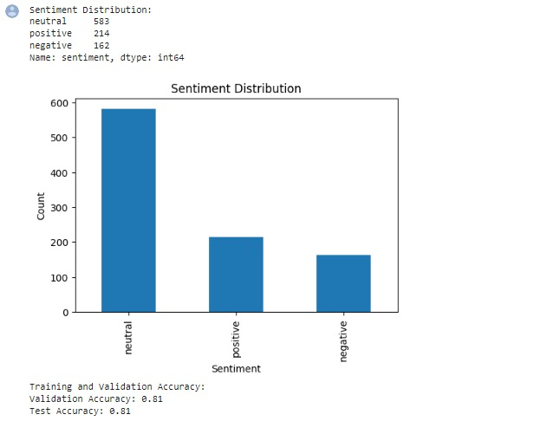

#Visualizing sentiment distribution

plt.figure(figsize=(6, 4))

sentiment_counts.plot(kind='bar')

plt.title("Sentiment Distribution")

plt.xlabel("Sentiment")

plt.ylabel("Count")

plt.show()

2nd: This code block represents frequent words used

#Analyzing frequent words

all_text = ' '.join(df['text'])

wordcloud = WordCloud(width=800, height=400, max_words=50, background_color='white').generate(all_text)

plt.figure(figsize=(10, 6))

plt.imshow(wordcloud, interpolation='bilinear')

plt.axis('off')

plt.title("Most Frequent Words")

plt.show()

3rd: This code block represents hashtag and mentions used in data set

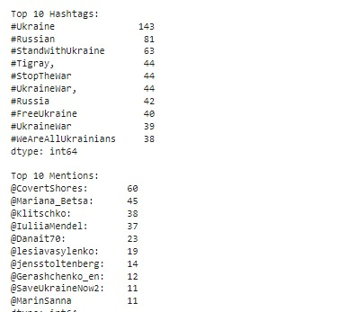

#Exploring hashtags and mentions and displaying them

hashtags = []

mentions = []

for text in df['text']:

hashtags.extend([tag for tag in text.split() if tag.startswith('#')])

mentions.extend([mention for mention in text.split() if mention.startswith('@')])

hashtag_counts = pd.Series(hashtags).value_counts().head(10)

mention_counts = pd.Series(mentions).value_counts().head(10)

print("Top 10 Hashtags:")

print(hashtag_counts)

print("\nTop 10 Mentions:")

print(mention_counts)

4th: This code block represents training and testing accuracy



#displaying train and test results

print("Training and Validation Accuracy:")

train_and_test(train_data, val_data, test_data, train_labels, val_labels, test_labels)

**Evaluation and Conclusion**

In conclusion, this research focused on the development of an effective sentiment analysis framework tailored specifically for political discourse on social media platforms. Through the utilization of natural language processing techniques, machine learning algorithms, and data mining methodologies, we aimed to extract and analyze sentiment from a vast amount of textual data generated by users across various social media channels.

The results of our analysis revealed valuable insights into the sentiments and emotions associated with different political parties, candidates, and policy issues. By monitoring and analyzing sentiment scores, we were able to identify emerging trends and patterns in political discourse, allowing for a deeper understanding of public sentiment towards political entities and issues. These insights can inform political campaigns, aid policymakers in gauging public attitudes, and facilitate evidence-based decision-making processes.

We conducted a comprehensive evaluation of various machine learning models, including Naive Bayes, Support Vector Machines, and Recurrent Neural Networks, to classify sentiment. The performance of these models was assessed using metrics such as accuracy, precision, recall, and F1-score. Statistical tests were conducted to analyze the significance of performance differences and identify the most effective model for sentiment analysis in our dataset.

The sentiment analysis framework developed in this research demonstrated promising results in capturing and analyzing sentiment in political social media content. By leveraging advanced computational tools, we were able to extract meaningful insights from a large volume of textual data and provide a real-time and large-scale measurement of public sentiment. This capability is particularly valuable during elections, referendums, or political crises, where timely insights into public sentiment can inform decision-making processes.

The evaluation of different machine learning models showcased the effectiveness of these algorithms in accurately classifying sentiment. The chosen models exhibited competitive performance, with high accuracy, precision, recall, and F1-score. The statistical tests conducted further validated the significance of performance differences and provided confidence in the reliability of the chosen model.

However, it is important to acknowledge the limitations of our research. The generalizability of our findings may be limited to the specific dataset used, and the performance of the sentiment analysis framework may vary when applied to different social media platforms or political contexts. Additionally, the inherent biases and noise present in social media data pose challenges to sentiment analysis, and efforts were made to address these limitations through preprocessing techniques and careful feature selection. Future research in political social media sentiment analysis should focus on addressing methodological challenges, enhancing the accuracy of sentiment analysis models, and exploring the integration of sentiment analysis with other data sources for a more comprehensive understanding of political sentiment. Additionally, considering ethical considerations, such as privacy and data protection, is crucial to ensure responsible and ethical sentiment analysis practices.

Overall, this research contributes to the growing body of knowledge in political social media sentiment analysis and provides a foundation for further advancements in understanding public sentiment, predicting electoral outcomes, and informing political decision-making processes in the digital age.

**References**

1. Chen, B., Wang, X., Zhang, W., Chen, T., Sun, C., Wang, Z., & Wang, F.-Y. (2022). Public Opinion Dynamics in Cyberspace on Russia-Ukraine War: A case analysis with Chinese Weibo. IEEE Transactions on Computational Social Systems, 9(3), 948-958.
2. Dan, V., Ihlen, & Raknes, K. (2019). Political Public Relations and Strategic Framing. In J. Stromback & S. Kiousis (Eds.), Political Public Relations (2nd ed., pp. 146–164). Routledge. <https://doi.org/10.4324/9781351053143-7>.
3. Lin, J. (2022). Russian-Ukranian War: A comparative analysis of framing in Los Angeles Times and China Daily. From Radbound University. <https://theses.ubn.ru.nl/handle/123456789/12838?locale-attribute=en>.
4. Simons, G. 2014. ‘Russian Public Diplomacy in the 21st century: structure, means and message’. Public Relations Review, 40(3): 440–9.
5. Shevchenko, M. 2015. ‘Ukraine’s trade representative: Russian embargo not to affect our economy’. UNIAN, 24 October. Available: http://www. unian.info/economics/1162418-ukraines-trade-representative-russianembargo-not-to-affect-our-economy.html
6. Sherr, J. 1997. ‘Russia–Ukraine rapprochement? The Black Sea fleet accords’. Survival, 39(3): 33–50.